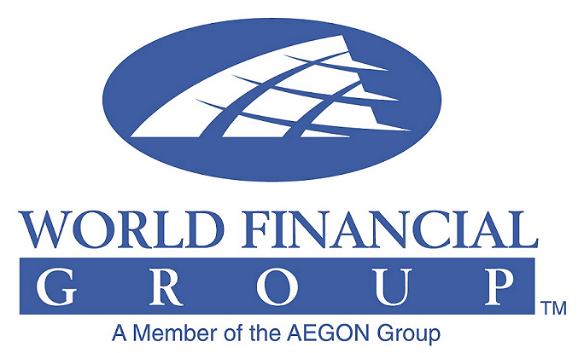

CORPORATE ANNOUNCEMENT
_______________________________________________________________________________________

Susan Sosoo joins the WFG Team

Inst New Associates Picture Here

DULUTH, Georgia March 05, 2010 – World Financial Group, Inc. (WFG) announced today that Susan Sosoo has contracted with the company as an independent associate to help meet the financial needs of consumers in the greater New York area.
Susan’s focus will include introducing consumers to the opportunities that exist at WFG, expanding its local clientele and increasing its base of financial professionals. She will be supported by, and have access to, a dedicated team of experienced field leaders and industry professionals committed exclusively to her success. As part of WFG’s Business Format System, Susan will complete her initial training; formal financial services training as well as her insurance licensing and securities registration.
Commenting on the new association, Winston Thompson, local WFG Marketing Director, said, “We are delighted to add someone of Susan’s caliber to our team. Her enthusiasm, insight, commitment, team spirit and understanding of the value of professionalism, leadership and mentoring were major factors in our decision to associate with Susan, and we look forward to her contributions to our organization and initiatives.”
Ms Sosoo currently resides in Brooklyn New York with her family.
About World Financial Group, Inc.
World Financial Group, Inc. (WFG) is an independent marketing company whose affiliates offer life insurance and a broad array of financial products and services. Through its thousands of independent associates in the United States and Canada, World Financial Group strives to help individuals and families who are often overlooked by the financial services industry to plan for their financial futures and work toward their goals no matter what their income.
World Financial Group does not have a “one size fit all” attitude regarding products and providers, instead WFG believes in the power of choice for its clients. World Financial Group has agreements with more than 70 separate insurance and financial services companies,* giving WFG associates the opportunity to offer clients a wide variety of products and services, so they can choose the ones that best fit their needs.
World Financial Group is a member of a respected corporate family - the AEGON Group - one of the world’s leading insurance, pension and related financial services organizations.
For more information on World Financial Group, log on to www.worldfinancialgroup.com.

*Securities-related products and services are available only through those WFG associates who are registered representatives of World Group Securities, Inc. Insurance products are offered through World Financial Group Insurance Agency, Inc. WFG, WGS and WFGIA are affiliated companies.
World Financial Group—Helping you move from dreaming to doing®

